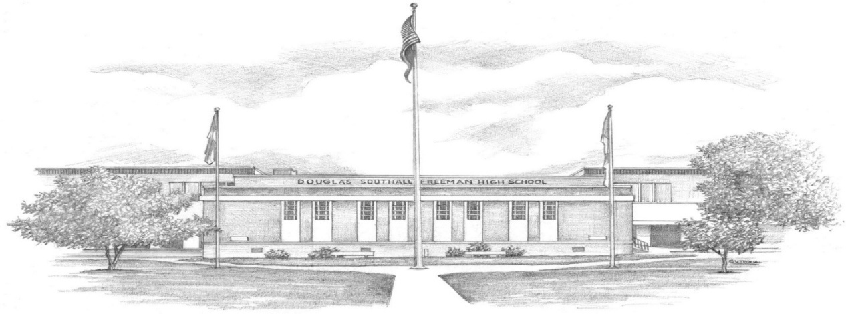

DSF 76 Saturday Night 50th Reunion Registration
October 17, 2026
-Current Name:
-Name as DSF Student:
-Name as you would like it on nametag:
-Current Address:
-Email Address:
-Phone Number:
-Number in Party:
-Name of Guest (s):
-Admission: $76 per person before October 1st.
$90 per person thereafter and at the door.

-You can pay online with Zelle
***When paying by Zelle, please note in comments section the name of the person making
payment, noting maiden name if not the same, and name of guest, if applicable.***
-If paying online, please email registration to dsfclassof1976@gmail.com

-Check payment made payable to DSF Class of 76 Reunion and mail to:
DSF Class of 1976, 12100 Farmer Court, Henrico, VA 23233
Please print this registration and enclose it with your check.
-Please direct any questions you have to dsfclassof1976@gmail.com
-Website: dsfclass76reunion.com

