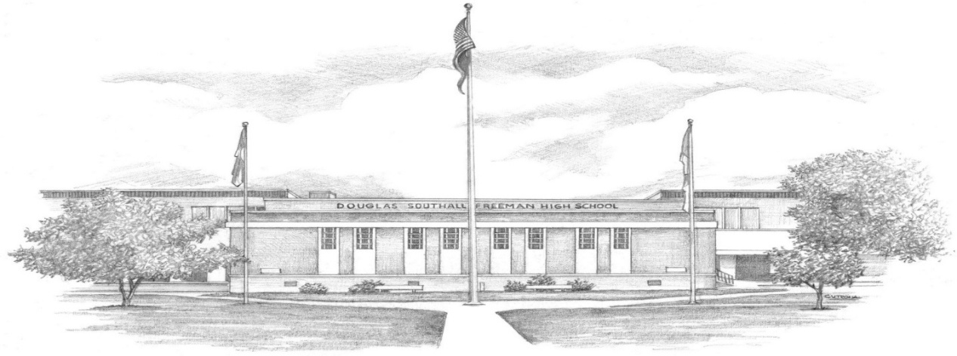

DSF 76 Saturday Night 50th Reunion Registration
October 17, 2026
-Current Name:
-Name as DSF Student:
-Name as you would like it on nametag:
-Current Address:
-Email Address:
-Phone Number:
-Number in Party:
-Name of Guest (s):
-Admission: $76 per person before October 1st.
$90 per person thereafter and at the door.

-You can pay online with Zelle
To use Zelle, you go into your bank account, either on your phone or computer, Click on the Zelle button. In the "send money to" section, you “search” our reunion email address and click on that. It will come up as 'send to Lisa Deane/ dsfclassof1976@gmail.com '.
Then you continue to fill in the information in each of the boxes. ***When paying by Zelle, please, in note section, fill in the name of the person making payment, noting maiden name if not the same, and name of guest, if applicable.*** If paying online, please download, fill out and email the registration to dsfclassof1976@gmail.com

-Please direct any questions you have to dsfclassof1976@gmail.com
-Website: dsfclass76reunion.com

